# To install the new subroutine

Copy testLocking.zip to your sys$login

$ unzip testlocking.zip

This will create a subdirectory [.testlocking]

$ @[.testlocking]testlocking

This sets up the environment for running the build.

$ copy build$root:[build]*.dbl; dblstarlet

This copies the correct FABDEF and NAMDEF files to DBLSTARLET. Of course you only need to do this first time you do this.

$ @build$root:[build]buildall BUILD$ROOT ALL TESTLOCKING

********************************************************************************

PROTOTYPING CLASSES FOR PROJECT TESTLOCKING

********************************************************************************

NOTHING TO DO...

********************************************************************************

BUILDING SUBROUTINES FOR PROJECT TESTLOCKING

********************************************************************************

PROCESSING: BUILD$ROOT:[SUBS]LOCKING.DBL;1 TYPE: SUB PROJECTNAME: TESTLOCKING

COMPILING

DBL /DEBUG /OBJ=OBJ: BUILD$ROOT:[SUBS]LOCKING.DBL;1

LIB/REPLACE/LOG OBJ:TESTLOCKING.OLB OBJ:LOCKING

%LIBRAR-S-REPLACED, module FINDLOCKS replaced in BUILD$ROOT:[OBJ]TESTLOCKING.OLB

;1

%LIBRAR-S-REPLACED, module TOSTRING replaced in BUILD$ROOT:[OBJ]TESTLOCKING.OLB;

1

%LIBRAR-S-REPLACED, module ADDSTRING replaced in BUILD$ROOT:[OBJ]TESTLOCKING.OLB

;1

%LIBRAR-S-REPLACED, module FORMAT_UNPRINTABLE replaced in BUILD$ROOT:[OBJ]TESTLO

CKING.OLB;1

%LIBRAR-S-REPLACED, module DBLPARSE replaced in BUILD$ROOT:[OBJ]TESTLOCKING.OLB;

1

********************************************************************************

BUILDING CLASSES FOR PROJECT TESTLOCKING

********************************************************************************

NOTHING TO DO...

********************************************************************************

BUILDING SHARED IMAGE FOR PROJECT TESTLOCKING

********************************************************************************

@COMS:TOOLS

%DCL-E-OPENIN, error opening BUILD$ROOT:[BUILD]TOOLS.COM; as input

-RMS-E-FNF, file not found

********************************************************************************

BUILDING MAINS FOR PROJECT TESTLOCKING

********************************************************************************

PROCESSING: BUILD$ROOT:[SOURCE]TESTLOCKING.DBL;1 TYPE: MAIN PROJECTNAME: TESTLOC

KING

COMPILING/LINKING DKA0:[USER.CBLUNDELL.TESTLOCKING.][SOURCE]TESTLOCKING.DBL;1

TO CREATE DKA0:[USER.CBLUNDELL.TESTLOCKING.][EXE]TESTLOCKING.EXE;

DBL /DEBUG /OBJ=OBJ: BUILD$ROOT:[SOURCE]TESTLOCKING.DBL;1

LINK /EXE=EXE: OBJ:TESTLOCKING, SYS$SHARE:SSQLRTL.OPT/OPTION, OPTIONS:TOOLS.OPT/

OPTION

$

If you’re using the Workbench and my remoteBuild utility from the code exchange

Copy testLocking.zip to your sys$login

$ unzip testlocking.zip

This will create a subdirectory [.testlocking]

$ copy build$root:[build]*.dbl; dblstarlet

This copies the correct FABDEF and NAMDEF files to DBLSTARLET. Of course you only need to do this first time you do this.

Then from the Workbench…

Open the Workspace file in the project directory

Start the BuildService from the build menu

Click connect on the BuildService

Click BuildProject from the Build menu

The output will look like the following.

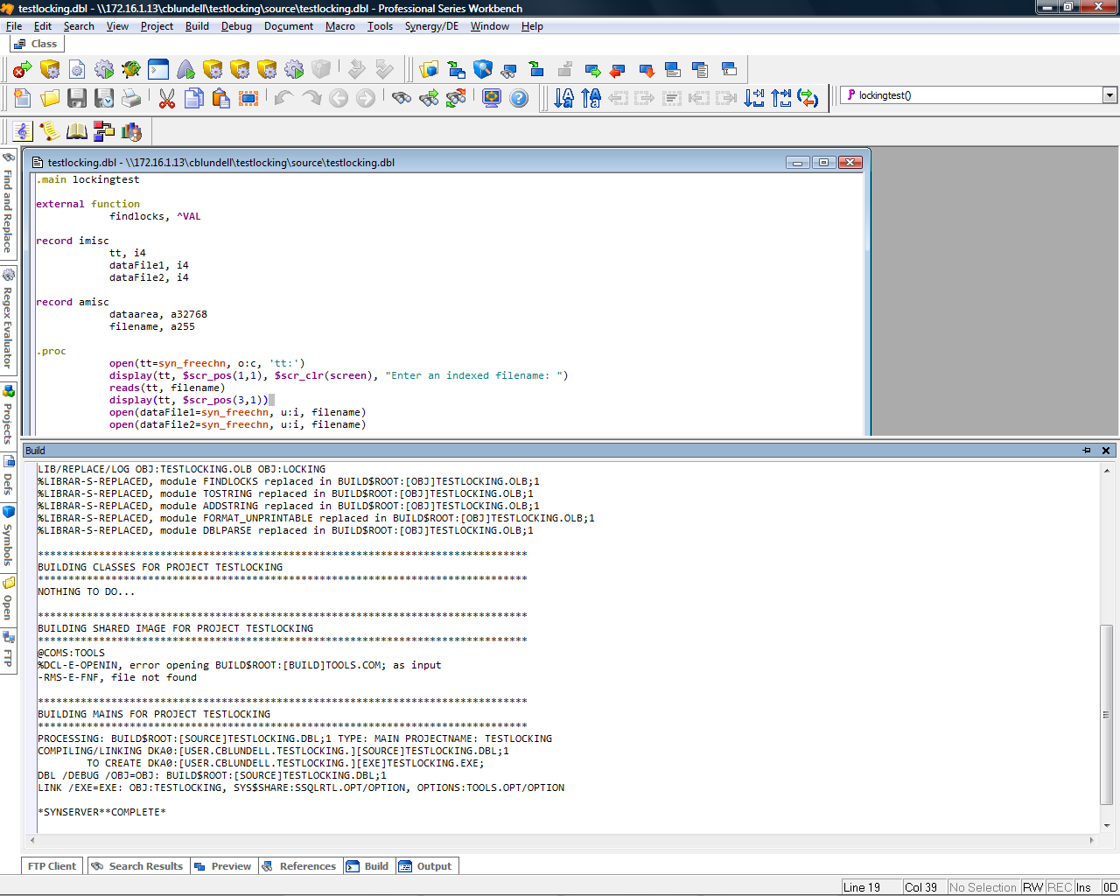

# Running the routine

$ RUN BUILD$ROOT:[EXE]TESTLOCKING

*** DEBUG 9.1.3 ***

Break at 16 in LOCKINGTEST (TESTLOCKING.DBL;1) on entry

16> open(tt=syn_freechn, o:c, 'tt:')

DblDbg> go

Enter an indexed filename: DATA:PROD

Process 00000131, "CBLUNDELL", User: CBLUNDELL on node: SIVMS

running DKA0:[USER.CBLUNDELL.TESTLOCKING.][EXE]TESTLOCKING.EXE;70 at _TNA3:

Has a lock on SIVMS$DKA100:[DATA]PROD.ISM;2

VBN = 6, ID = 1, MODE = 4

A 02630673 1110 11 N YN

Key 0: "A "

Key 1: " "

Key 2: " "

Key 3: "A 11 N "

Key 4: "A "

Key 5: "AYYNYY "

Key 6: "A "

Key 7: "A "

Key 8: "A ("

Key 9: "A "

Key 10: "A536 "

Key 11: "A N "

%DBL-S-STPMSG, STOP

-DBL-I-ATLINE, At line 34 in routine LOCKINGTEST (TESTLOCKING.DBL;1)

$